**INSTITUTE OF SCIENCE AND TECHNOLOGY AUSTRIA**

**(IST AUSTRIA)**

DOC Fellowship proposal

# Spin dynamics of a hole spin qubit measured with gate reflectometry

**Applicant: JOSIP KUKUČKA**

**PhD thesis supervisor: Ass. Prof. GEORGIOS KATSAROS**

Klosterneuburg, September 2016.

Contents

[Project description: 2](#_Toc462309039)

[1. Background 2](#_Toc462309040)

[State of the art 2](#_Toc462309041)

[Measurement techniques 5](#_Toc462309042)

[2. Objectives of the project 7](#_Toc462309043)

[Definition of the problem 7](#_Toc462309044)

[3. Innovative aspects of the proposed project 8](#_Toc462309045)

[4. Preliminary results 8](#_Toc462309046)

[Low temperature electronic transport measurements with the initial version reflectometry setup 11](#_Toc462309047)

[5. Working plan 12](#_Toc462309048)

[Towards gate reflectometry 12](#_Toc462309049)

[Spin dynamics experiments 14](#_Toc462309050)

[6. Work table 18](#_Toc462309051)

[7. International collaborations 18](#_Toc462309052)

[8. Contingency plan: 18](#_Toc462309053)

[References: 19](#_Toc462309054)

# Project description:

## Background

### State of the art

One of the hottest topics in condensed matter physics is the realization of a quantum computer. The main advantage of such a quantum computer would be its ability to solve specific classes of algorithms orders of magnitudes faster than classical computers. A classical computer is based on deterministic two level states called bits. A quantum computer is also based on two level states (basis states) called quantum bits (qubits). However, a qubit, unlike a classical bit, exploits the quantum effect of superposition. As a consequence, a quantum system can be simultaneously in both basis states.

There have been several proposals for implementing such a qubit, with just some solid state realizations listed below:

* Semiconductors:
  + - Nuclear spin qubits [1]
    - Electron (hole) spin qubits [2]
* Superconductors:
  + - Flux qubits [3]
    - Charge qubits [4]

One of the above mentioned suggestions, which came in 1998 by Loss and DiVincenzo, was to use the spin of electrons (holes) for the realization of a qubit. The spin, an intrinsic quantum mechanical property of every elementary particle, lifts the degeneracy of an orbital energy level in the presence of an external magnetic field. The orbital level splits into two, typically labelled as spin-up and spin-down. This two level system can then act as a qubit, the so-called spin qubit.

However, for creating and manipulating the spin qubit, one must first confine a charge particle into a region, which is in size comparable to a charge particle wavelength. Such a confinement can take place in a structure called quantum dot (QD). QDs are very small structures (their diameters can reach tens of nanometers) and because of their almost zero dimensionality, the energy levels for a charge particle are discrete and far away from each other.

Not every two level system can create a useful qubit for the realization of a scalable quantum computer. In 1998 DiVincenzo published a list of conditions which a qubit should fulfill for a quantum computer to work correctly [5]:

The 5 necessary criteria are:

* **The qubit should be well-defined:** A well-defined qubit is a two level (two state) system whose levels are distinguishable and highly controllable.
* **It should allow reliable state preparation:** The qubit needs to be deterministically driven into the initial state to enable the next computational step to take place**.**
* **It should show low decoherence times (long coherence times):** Because of the several noise sources to which a qubit is exposed its initially prepared state is lost (it does decohere) with time. It is desirable to have coherence times as long as possible.
* **A “universal” set of quantum gates which perform the state manipulations, should exist:** In the classical logic the Boolean function set (set of gates) is functionally complete or universal if any other function (gate) can be represented by it. The same functional universality applies for the quantum logic.
* **A qubit measurement capability (state readout) should exist:** After several state manipulations have been applied to the qubit, one should be able to read out the computed result, it’s quantum state.

**For all types of qubits it is desirable to have the manipulation time as small as possible and the coherence time as large as possible. For performing quantum computation, many single operations need to be done before the system decoheres. The benchmark for the manipulation time is the minimum time needed for going from one state to the other (full spin rotation time).**

**For spin qubits, which this proposal deals with, different materials have been investigated aiming to find the material with the highest coherence vs manipulation time ratio.**

**Materials**

Silicon **(Si)** has emerged as a promising material for the realization of spin qubits because it can be isotopically purified and left just with the 28Si isotope which is a zero nuclear spin element. Thus the nuclear noise can be eliminated and the coherence time boosted in comparison to the broadly used gallium arsenide (GaAs) [6]. The additional big advantage of Si is its compatibility with current CMOS technology. This could become very important when moving towards the realization of a large number of qubits as required by quantum algorithms.

There are several approaches of defining QDs in silicon.

One way is by means of a phosphorous (P) dopant. In that case a P atom behaves as an electron QD because of its confining potential. Andrea Morello’s Group at UNSW in Australia, by applying the spin echo pulse sequence, has measured electron spin coherence time T2ECHO exceeding 200 microseconds, in a non – isotopically purified Si:P system, while the duration of one full spin rotation (τπ) in this case was τπ = 150 ns [2]. By using isotopically purified 28Si:P samples, Muhonen et al. have measured spin coherence times using the CPMG pulsing technique of T2CPMG > 0.5s and τπ ≈ 3 μs [7].

M. Veldhorst et al., by using lithographically defined electron QDs in Si, have measured T2CPMG = 28 ms and τπ = 1.5 μs [8]. Finally, E. Kawakami et al. by using a single-electron QD in a Si/SiGe heterostructure qubit, have measured T2ECHO = 40 μs, while τπ = 0.15 μs [9].

One limitation of Si is the difficulty to perform fast gate operations while maintaining the good coherence. One way around this problem is to use the spin-orbit interaction of holes instead of electrons and perform spin manipulation via electric fields (as described in more detail in the *Spin dynamics experiments* section). Using this approach, R. Maurand et al. realized very recently the first CMOS spin qubit by using a hole confined in a transistor made out of p-type Si. Indeed, the time for a full spin rotation was much reduced τπ ≈ 6 ns but also the reported T2ECHO ≈245 ns [10].

**Holes in** **germanium** **(Ge)**, have an even higher spin orbit coupling which should allow thus much **faster spin manipulation times**. In addition, for purely heavy-hole (HH) states the **dephasing time should be very long** [11].

In our group we study qubits in Ge self-assembled nanostructures [12], which are created by epitaxial growth of Ge on Si. Such a growth can lead to various types of nanostructures. In this project the so-called Ge hut-wires are going to be studied. Very recently magnetotransport measurements have shown that holes, in this type of structures, are of HH character [12], suggesting long coherence times for this material system.

**C:\Users\jkukucka\Documents\GitHub\Fellowship\Diamond_Hannes.tif**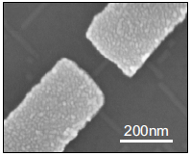

Figure 1: Stability diagram of a SiGe hut-wire single QD (left). Scanning electron micrograph of a Ge hut-wire contacted by palladium (Pd) source and drain electrodes (right) [12]

### Measurement techniques

Different type of measurement techniques have been used in order to extract the state of a spin qubit and its coherence time:

* DC current readout: The DC current readout is sensing the hole transport through the qubit by means of current measurement. It is prone to low frequency 1/f noise and the bandwidth (BW) is low because of heavy filtering necessary for achieving low effective electron temperatures.
* Differential measurement (AC current readout): The differential measurement (AC current readout) has similar drawbacks as the DC current readout. It is typically done with a low frequency lock-in technique. Because of the low frequency noise, a lock-in amplifier usually operates on a very narrow BW around the measurement frequency, which leads to long measurement times.
* Ohmic reflectometry: Ohmic reflectometry is a technique which indirectly senses the impedance change of a QD by monitoring the amplitude or phase of the reflected wave from the QD (see Figure 2 for a more detailed explanation). It is usually performed by high frequency lock-in techniques and is not prone to 1/f noise.
* Gate reflectometry: Similar to the ohmic reflectometry but it is connected to a gate electrode and not to a source or a drain. **It’s big advantage is that it does neither require charge transport through the QD hosting the qubit nor the existence of a charge sensor typically used with ohmic reflectometry.**

**Explanatory box: What is reflectometry?**

****

Figure 2: Basic principle of ohmic reflectometry. The resonant circuit consists of the single hole transistor (SHT) and the matching circuit. The SHT is represented with a parallel combination of CS and RS. S and D denote the source and drain contacts of the SHT, respectively. The matching circuit formed with an inductor L and a capacitance C is connected to the source contact.

Reflectometry is a readout technique based on the change of the wave reflection coefficient Γ. It comes from the electromagnetic wave principle – if a wave is travelling in a media with impedance Z0  (e.g. coaxial cable) and it encounters a change of impedance from Z0 to Z (e.g. end of coaxial cable), a portion of the wave will be reflected back according to the expression:, where Ar is the amplitude of the reflected wave, Ain the amplitude of the incoming wave and Γ is the reflection coefficient.

By using a resonant circuit (matching circuit with an incorporated SHT) as showed in Figure 2, instead of the open end of a coaxial cable, one can make use of the information contained in the reflected wave amplitude. For achieving this, the elements of the resonant circuit, the inductance L and the capacitance C needs to be chosen to achieve the matching condition on the resonant frequency f0 of the circuit, . Matching condition is the situation in which the typically large resistance (~100 kΩ) of the SHT is transformed, by the inductor and capacitor, to near 50 Ω. This value is the characteristic impedance of the RF line (Z0), thus the wave reflection coefficient Γ is minimized. In that case the sensitivity is maximized [13] and small changes in the SHT impedance results in an observable change in the reflected wave amplitude.

## Objectives of the project

The aim of this project is the realization of a hole spin qubit in a so far unexplored type of material system, namely Ge hut-wires. To goal is to achieve as long coherence times as possible with as short as possible manipulation times. More concretely, the first measurements to be performed are the ones for determining the spin relaxation time T1 . Subsequently, experiments in order to investigate the coherence times of the qubit are going to be performed. Spin manipulation experiments for measuring the spin dephasing time T2\*, the spin coherence time using spin echo technique T2ECHO, and the spin coherence time using the Carr-Purcell-Meiboom-Gill (CPMG) pulse sequence technique T2CPMG, are going to be conducted.

### Definition of the problem

**Since charge transport through the QD hosting the qubit is in many qubit experiments unwanted because it is an invasive method, many groups use charge sensors (quantum point contacts or QDs) for reading out the state of the qubit.** The charge sensor is electrostatically coupled and thus sensitive to the charge configuration in the qubit. The charge sensor itself is well coupled to ohmic contacts and therefore it is suitable for charge transport measurements (DC current readout, AC current readout) and ohmic reflectometry.

**However, charge sensors suffer from thermal broadening of the conductance features (coulomb peaks, conductance plateaus) which lowers the sensitivity and thus the readout speed. In addition, their gate voltage needs also to be continuously adapted in order to compensate the influence of the qubit gates on their conductance. Finally, by looking into the future, for the realization of a usable quantum processor, the qubit number needs to be drastically scaled up. Adding charge sensors next to each qubit leads to additional complexity.**

**I will read out the state of the qubits by means of gate reflectometry. Gate reflectometry does not suffer from the previously listed problems.**

By connecting the gate electrodes defined for creating and tuning a GaAs/AlGaAs heterostructure double quantum dot (DQD) to a lumped element matching circuit, J. I. Colless et al. achieved a charge sensitivity of 6.3 meHz-1/2 [14]. Last year, M.F. Gonzalez – Zalba et al. reported an improved charge sensitivity of 37 μeHz-1/2 by using a similar gate reflectometry approach for a silicon nanowire based DQD device [15]. The reported sensitivity is better than achieved with ohmic reflectometry in charge sensors such as 100 μeHz-1/2 for the RF quantum point contact [16], but still worse than reported 1 μeHz-1/2 for the RF single electron transistor [17]. In this work the goal is to achieve a charge sensitivity comparable or even faster than the one achieved for ohmic reflectometry. That will allow us to have a high BW system necessary for the qubit measurements, in particular for various type of single-shot experiments.

## Innovative aspects of the proposed project

In this project a hole spin qubit in a DQD formed in a Ge hut-wire will be studied. Despite the interesting electronic properties of this type of nanostructure nothing is known about the spin lifetimes of the confined holes. Due to the low hyperfine interaction and the HH character of the wave function very long dephasing times are expected [12],[11]. In addition, easy and fast spin state manipulation should be possible because of the in situ present **large spin orbit coupling** for holes in Ge. This will also eliminate the necessity for an oscillatory magnetic field. Such a manipulation by means of oscillatory electric fields in combination with the gate reflectometry will dramatically reduce the fabrication complexity since no extra structures (charge sensor, strip line) are required except of the already defined and necessary gates. Thus this approach has high chances of **addressing the challenge of scalability**.

Finally we aim to achieve the highest reported sensitivity in the gate reflectometry setup. The gates in our DQD system are positioned very closely to the hut-wire (less than 4nm – defined simply by the thickness of the dielectric) in which the QDs are formed. This implies **high capacitive coupling between gate and QDs and as a consequence a high speed of the gate reflectometry setup,** as will be explained below.

## Preliminary results

During the first year of my PhD I have already prepared a 4K dip stick (Figure 3) for reflectometry measurements. Particular attention was paid to the sample holder, fabricated as a printed circuit board (PCB). DC electrical signals are sent to the sample through low thermal conductive wires twisted in pairs finishing in a PCB connector; radio frequency (RF) signals are sent through the coaxial cables. The DC signals are low pass filtered with surface mounted RC filters (Figure 4) to reduce thermal noise from the wires. After low pass filtering, the DC signals are routed to the gold plated bonding pads around the area in the middle of the PCB (sample area) on which a typically 5x5 mm2 sample is glued with the silver paste (Figure 4). The RF coaxial lines are finishing on the PCB mounted SMP connectors (Figure 4). After the SMP connector, a DC signal is added to the RF signal using a bias tee. From there the signal is routed to the PCB bonding pads. Electrical contacts from the PCB bonding pads to the sample bonding pads are achieved by wedge wire bonding.

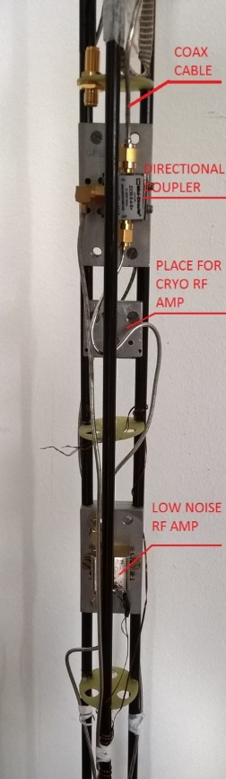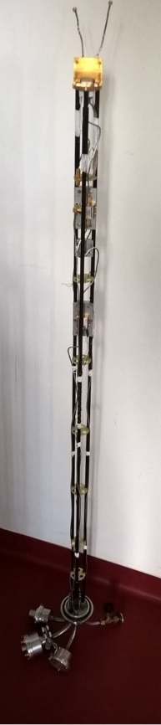Figure 3: The plexiglas 4K dip-stick used for cooling down the samples to 4K and performing the reflectometry measurements. The left picture shows the whole stick, while the right is a zoom-in, highlighting the directional coupler and the low noise Minicircuits ZX60-33LN-S+ RF amplifier. An additional low noise cryogenic RF amplifier CITLF2 from Sander Weinreb’s Caltech Microwave Research Group can be added in order to increase the SNR of the measured signal.

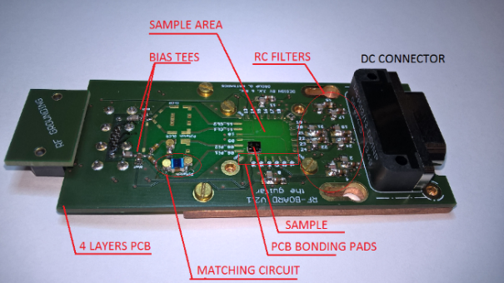Figure 4: Initial version of the PCB sample holder for the ohmic reflectometry. The upper figure shows the upper view of the PCB while the lower figure focuses on the back side.

**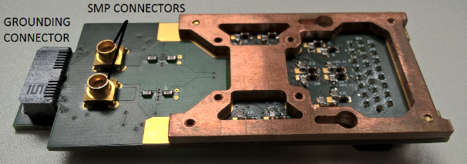**

The resonant circuit consists of a matching circuit (Figure 4) and the SHT. The SHT is schematically presented as the resistance RS in parallel to the capacitance CS, as can be seen in the simple circuit model in Figure 2. For the matching circuit, the surface mounted inductor Murata 1.2 μH and the varactor MACOM MA46H070-1056 were used. The Varactor – a voltage tunable capacitor - was used in order to

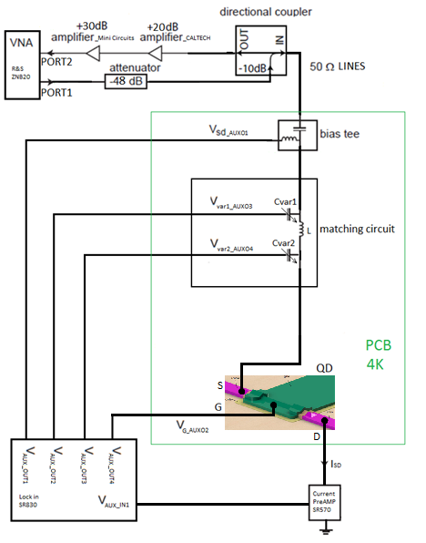Figure 5: Simplified schematic of the overall ohmic reflectometry measurement circuit

be able to always achieve a good matching condition.

For performing ohmic reflectometry measurements the RF signal was sent from VNA port 1 down the coax line (Figure 5) towards a QD device. The signal which gets reflected from the resonant circuit is sent via the directional coupler to the amplifiers. The amplifiers configuration, shown in Figure 5, is used to preserve the signal to noise ratio (SNR). After the sample, the very low noise cryogenic amplifier, Weinreb’s CITLF2, is used to amplify both signal and noise by the same amount (around 20 dB), adding a very small amount of itself noise, thus almost equalizing the SNR on its input with the SNR on its output. Thus higher noise level on the output of the CITLF2 amplifier allows the second, noisier amplifier to achieve the SNR on its output approximately the same as the SNR on its input. Such an amplifier chain enables non – degrading propagation of the SNR from the sample stage to the higher noise, room temperature electronics.

For conducting the measurements several instruments have been used.

* Reflection coefficient measurement: vector network analyzer (VNA) from Rohde and Schwarz, model ZNB20
* DC biasing of the single hole transistor: auxiliary bias outputs of a Stanford Research SR830 lock-in amplifier
* DC current measurements: current amplifier from Stanford Research SR570
* For attenuating the RF signal sent to the sample: Minicircuit’s attenuator
* For amplifying the RF signal reflected from the sample: series of CITLF2 and Minicircuit’s low noise amplifier
* Instrument control and data retrieval to the PC: Python application.

### Low temperature electronic transport measurements with the initial version reflectometry setup

The SHT sample was fabricated by H. Watzinger, as well PhD student in the group, and the nanofabrication description can be found in [12]. Using the setup described above, the SHT (single QD) formed in the germanium hut-wire (Figure 6, left) was tuned in the Coulomb blockade regime applying DC voltages on source, drain and gate electrodes (Figure 5). Charge stability measurements were conducted in the Coulomb blockade regime showing a Coulomb diamond pattern. A comparison of the DC current and the ohmic reflectometry measurements has been done. The DC current was measured by applying a bias on the source and reading the current from the drain contact (Figure 5), while for the reflectometry measurement the LC matching circuit was connected to the SHT source contact (Figure 5).

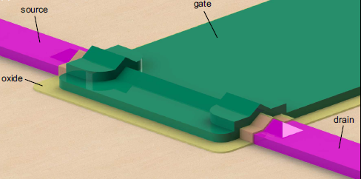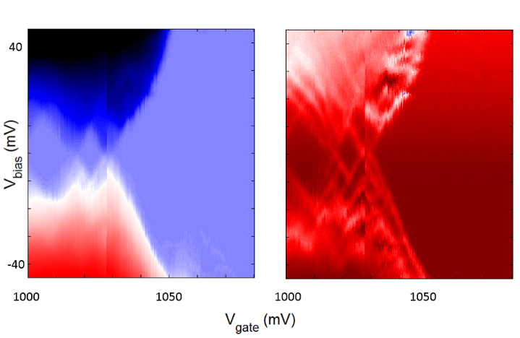

Figure 6: (Left) 3D model of a SiGe nanowire-based single QD sample [12]. A single QD which confines holes is formed in the nanowire beneath the gate (green). Comparison of the DC current transport (middle) and the ohmic reflectometry (right) measurements on the SHT in a Ge hut-wire.

By adjusting the integration time to be similar for both measurements, it can be seen that the reflectometry technique enables us to see more features like the excited orbital energy states of the SHT (Figure 6, middle and right).

We have compared our reflectometry setup with the one of D. J. Reilly et al. for which they reported conductance sensitivity of 5\*10-6 e2/h Hz−1/2 by performing reflectometry on a quantum point contact in a dilution fridge with electron temperature of 120 mK [18].

We have measured a just around five times lower sensitivity despite the much higher temperature of 4K. This is quite good when considering that the thermal broadening of the energy levels at 4K leads to much wider coulomb peaks. Such results in a much smaller resistance change for a small gate voltage modulation and thus a smaller sensitivity.

## Working plan

### Towards gate reflectometry

The first generation of the used setup and the PCB board aimed to verify that indeed we have the knowhow to perform RF reflectometry measurements. The second generation of the reflectometry setup will be developed during this project and installed in a dilution fridge reaching temperatures down to 10 mK.

For the purpose of measuring several samples and due to the necessity for a higher number of RF lines, dictated by the spin manipulation experiments, a new PCB will be designed. The new design will allow frequency multiplexing of four different reflectometry resonant circuits. We will install in the dilution fridge insert a similar reflectometry system like the one used in the 4K dip-stick. However there will be several improvements. There will be an upgrade in terms of using lower thermal conducting stainless steel cables, attenuators, and additional DC filtering of all the DC wires. In addition, a Niobium titanium superconducting cable is going to be used between the input of the cryogenic amplifier and the sample stage because of its very low thermal conduction, to avoid heating of the mixing chamber stage of the fridge which has a cooling power of a few tens of μW in the insert.

The vector network analyzer which was used so far for the measurements will be replaced with a Zurich Instruments UHF lock in amplifier which enables faster and longer data acquisition, more inputs and generally more measurement flexibility. For the spin relaxation time and the spin manipulation measurements, to be described below, arbitrary waveform microsecond pulses with a nanosecond rise time are needed. Those are generated using a Tektronix arbitrary waveform generator (AWG) 5014C. The measurements will be conducted using the QTLab measurement application developed in Python initially by the Delft Quantum Transport (QT) laboratory. We modified it according to our needs. All the codes can be found on the GitHub: <https://github.com/nanoelectronics-new/qtlab>

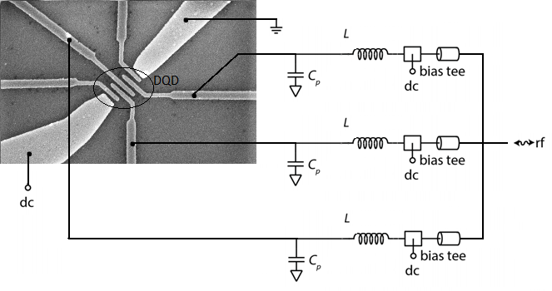Figure 7. Gate reflectometry schematic on the Ge hut-wire DQD sample, fabricated in our group. LC resonators are connected to the three gates. Because of the different inductor L values, the resonance frequencies of the three matching circuits are different enabling thus the so-called frequency multiplexing technique.

As in the ohmic reflectometry, also for the gate reflectometry the readout parameters are the phase shift ∆φ and the amplitude change ∆γ of the reflected signal due to the charge configuration change in a QD or a DQD. They are expressed as: , , , where Q is the quality factor of the resonant circuit, Cp is the parasitic capacitance, Cg is the gate to dot coupling capacitance and CΣ is the overall QD capacitance [15]. The capacitance Cg can be approximated with a parallel plate capacitor since the gate electrode and the hut-wire separated by a thin dielectric, form such a capacitor. From the above expressions it can be seen that a higher coupling between a gate and a QD (higher Cg) leads to higher sensitivity of both ∆φ and ∆γ.

From the equation for ∆φ, it is clear that there are two factors which are critical for getting a sensitive gate reflectometry setup. Firstly to **reduce the parasitic capacitance** **Cp** as much as possible by engineering the sample holder. Secondly, to **achieve high quality factor Q** of the resonant circuit.

For **reducing the parasitic capacitance Cp,,** simulations of the PCB RF lines and bonding pads geometric capacitance in respect to their dimensions, routing configuration and PCB dielectric will be performed.

**The quality factor Q** dependence on different inductors and capacitors will be examined.

There are some additional losses that lower sensitivity of gate reflectometry, namely PCB dielectric losses and losses in the PCB RF transmission lines [15].

Losses in the PCB dielectric will be addressed by using a dielectric with lower dielectric loss then the currently used FR4, e.g. some of the Rogers Corporation laminates.

RF lines transmission losses come probably from the unwanted reflections due to the transmission line routing and splitting needed to connect more reflectometry readout circuits. This assumption should be tested and the **optimum configuration of the PCB RF lines** could be achieved by using the Sonnet software for simulating the RF line scattering parameters.

*Since I have already obtained quite some experience with reflectometry setups I expect that it will be feasible to realize a state of the art gate reflectometry setup within one year. In particular, since the group has five cryogenic setups, I will have enough time to characterize the reflectometry and optimize it.*

### Spin dynamics experiments

Once the gate reflectometry setup will be properly working, I will focus on performing spin manipulation experiments. During my PhD I will focus on the Loss-DiVincenzo spin qubit.

For achieving good state preparation, fast manipulation and fast measurement, additional mechanisms are required beyond ones offered by single QDs. One of the most promising building block for the realization of the spin based quantum computer is the DQD system. A DQD system consists of two neighboring QDs tunnel coupled to each other, which simply means that they can exchange charge particles via tunneling.

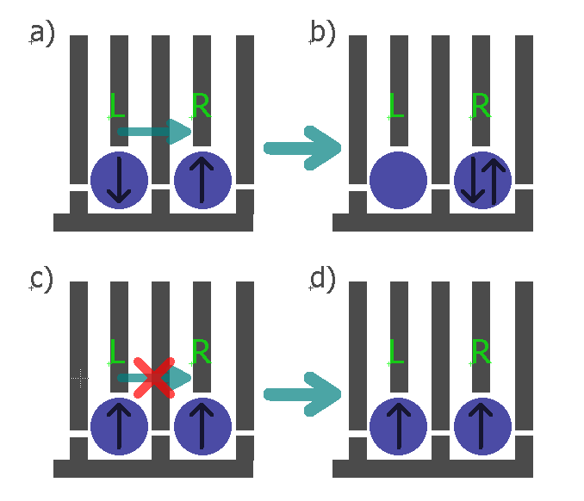Figure 8: Spin state readout based on the spin blockade, shown for a gate defined DQD. The blue circles represent the individual QDs. Grey lines represent the gates and the black arrows in the QDs the spin direction. The charge can tunnel from the left to the right dot just if the spin configuration, when the charges are separated in the two dots, forms a singlet.

The main physical property which makes them attractive for the implementation of a qubit is the Pauli exclusion principle. It says that two identical fermions (in this specific case electrons or holes) cannot occupy same energy state. Figure 8 describes how the Pauli exclusion principle can be used to extract information about the spin degree of freedom in the left QD in the DQD system. If the spin configuration forms a singlet state S(1,1) (the numbers in brackets denote the charge number on the left and right dot respectively), like shown in Figure 8a, then after electrostatic pushing, by applying voltage pulses on gates L and R, the charge is allowed to tunnel to the right dot, forming a singlet S(0,2) state (Figure 8b). In the case below (Figure 8c) charges in both dots have the same spin, forming a triplet T(1,1) state and due to Pauli exclusion principle they stay in the (1,1) configuration (Figure 8d) after electrostatic pushing, because the triplet state T(0,2) is too high in energy and thus not available. This effect is known under the name Spin blockade.

#### Measuring the spin relaxation time T1

For measuring the spin relaxation time, an approach similar to the approach of Koppens et al. [19] will be used. The DQD will be tuned to the (0,1)-(1,1)-(0,2) triple point. The left dot is initially empty while the right dot is populated with a charge in its spin ground state, a spin down hole. First, pulsing the gate of the left dot will bring its spin up and spin down energy levels above the Fermi level, μF, of the lead, allowing lead to dot hole tunneling (holes tunnel to higher lying electrochemical potentials). Since the tunneling is most likely spin independent, the left dot is loaded with a random hole spin from the lead during the loading time tL. The double dot is thus in either a singlet S(1,1) state or a triplet T(1,1) state and is left in that configuration for the waiting time tw. After tw, a second pulse level is applied in order to bring the hole from the left QD to the right QD. For a S(1,1) configuration tunneling will take place. As explained above, due to the spin blockade, this will not be the case for the T(1,1) state. If charge tunneling takes place between the two QDs, a shift in a quantum capacitance (a capacitance originating from a DQD charge polarization) will take place, which can be detected by the gate reflectometry. The probability of finding the DQD system in the S(1,1) state will decay exponentially with the duration of the waiting time tw, with *T*1 being the decay constant, since for long waiting times (tw >> *T*1) the DQD will always end up in the S(1,1) state.

*The samples needed for performing the T1 experiments are already existing in the group. H. Watzinger is currently performing DC measurements on such DQD devices. For the T1 experiments all the knowhow in the group is already existing, thus 6 months seem a realistic time for performing this experiment.*

#### Measuring the spin dephasing time T2\*

Quantum gate operations for a spin qubit system imply spin manipulation. Basically such manipulations are spin rotations in the spin representation sphere, called Bloch sphere.

Figure 9. Bloch sphere

The spin-up (north pole) and spin-down (south pole) states form the basis of a spin qubit and they are the Bloch sphere (Figure 9). Their energy splitting EZ is determined by the hole g factor g, the Bohr magneton μB and the static external magnetic field B, as . The spin vector precesses around the applied static magnetic field axis with a so-called Larmor frequency , where h is the Planck constant. For flipping the spin an external oscillatory magnetic field BAC needs to be applied perpendicular to the static one and its frequency needs to match the Larmor frequency. An intuitive understanding why the frequency of the BAC needs to match the Larmor frequency can be obtained by thinking of the example of a child on a swing. The child-swing system oscillates with its natural frequency of oscillation. If the swing is pushed by an external person with an appropriate period of pushing pulses, the amplitude of the oscillation will increase and at some point the swing will flip. In this comparison the natural frequency of a child-swing system corresponds to the Larmor frequency and the frequency of the externally applied pushing pulses to the frequency of the applied oscillatory magnetic field.

However, an oscillatory magnetic field is hard to implement, from the fabrication standpoint, since it adds more steps and thus the risk of failure. One way to avoid this problem is to a apply static instead of an oscillatory magnetic field and to apply an oscillatory voltage to the QD gate. The oscillatory electric field can modulate the hole g factor giving thus an equivalent to the first case, oscillatory magnetic field. Modulation of the hole g factor with the electric field is possible because of the spin-orbit coupling. This technique is called g-tensor modulation technique [20] and is going to be used in the qubit I am planning to study.

Microwave sources generating high frequency signals will be needed for this experiment; for a g-factor of 3 as expected in our system [12] and a typical magnetic field of around 0.5 T, the Larmor frequency is around 20 GHz. Actually, for this purpose a vector signal generator will be used, controlled also from the python measurement application.

In order to determine the coherence time, coherent spin manipulation is needed. To verify the coherent spin manipulation, Rabi oscillation experiments will be conducted. The DQD will be initialized in the T(1,1) charge configuration. Then the spin in the left dot will be rotated for an angle determined by the spin rotation time which is the time of the applied burst of the microwave signal, τBURST. In the next step, voltage pulses are going to be applied trying to push the DQD to the (0,2) charge configuration (which is a singlet S(0,2) configuration as explained already above). By linearly changing τBURST, a Rabi oscillation pattern of the S(0,2) configuration probability should be observed proving the coherent spin manipulation [10].

Following the approach of R. Maurand et al., for evaluating the inhomogeneous dephasing time T2\*, Ramsey – fringes like experiments will be conducted [10]. Starting from the T(1,1) state a pulse rotating the left spin around the x axis for the ∏/2 angle (∏/2 pulse) will be applied to bring the spin vector from the spin up state to the xy plane in Figure 9. It will stay there for the time τ being thus exposed to the dephasing noise. After time τ, a second ∏/2 pulse around the x axis will project the spin vector back on the z axis. If no dephasing has taken place, the spin should finish at the south pole of the Bloch sphere (spin down state) forming the S(1,1) state which result in S(0,2) state in readout stage. Linear increase of the τ between the measurement points will result in the exponentially decaying S(0,2) probability, with T2\* being the decay constant.

*I anticipate that I will need one year for determining T2\* in our qubit. For such an experiment one needs additionally a microwave signal source, one needs to synchronize the AWG with the microwave source and furthermore I will need to learn how to correctly apply the combined pulses avoiding thus gate errors.*

#### Measuring Spin echo T2ECHO

Coherence can be extended by the so called spin echo technique which can partially cancel dephasing originating, for example, from slow varying nuclear magnetic field or applied field inhomogeneities. Similar to the spin dephasing time measurement, the left spin vector is initially set along the north pole. Then, ∏/2 pulse around the x axis rotates it to the xy plane. Because of the dephasing sources the spin will dephase in the xy plane for time τ. Then a ∏ pulse around the y axis will be applied, which mirrors the spin vector around the y axis. The spin is then left to dephase for the same time, but since it will be mirrored, the direction of this dephasing will cancel the previous one, causing the so-called spin refocusing. Followed by another ∏/2pulse around x axis, the spin will be projected back to the z axis. From the exponentially decaying envelope of S(0,2) state probability in this case the T2ECHO will be extracted.

#### Measuring T2CPMG

Finally, in order to extend further the coherence time we will use the sequence of ∏ pulses called the CPMG sequence. The ∏ pulses, rotating the spin around the y axis can be applied at the times τ, 3τ, 5τ…, instead of a single ∏ pulse, as in the spin echo experiment, for the spin refocusing. Coherence time T2CPMG will be extracted from the exponentially decaying envelope of S(0,2) state probability vs the ∏ pulses separation time τ. This method is insensitive to the ∏ pulse length errors because the rotation axis alternates between y and –y subtracting thus the pulse length errors [7].

*For measuring T2ECHO and T2CPMG one more year will be needed. In principle after determining the dephasing time it should be straight forward to measure the coherence times however always unexpected problems might appear. In addition in between the experiments I expect also to write at least two papers. One dealing with the spin relaxation time and the second one with the dephasing/decoherence times.*

## Work table

|  |  |  |  |  |  |  |
| --- | --- | --- | --- | --- | --- | --- |
| **Aims** | 1st-6th month | 7th-12th month | 13th-18th month | 19th-24th month | 25th- 31st month | 32nd- 36th month |
| Towards gate reflectometry | X | X |  |  |  |  |
| Measuring the spin relaxation time T1 |  |  | X |  |  |  |
| Measuring the spin dephasing time T2\* |  |  |  | X | X |  |
| Measuring Spin echo T2ECHO and T2CPMG |  |  |  |  | X | X |

## International collaborations

We are collaborating with the spin qubit team in the group of C. Marcus in Copenhagen, led by **Ferdinand Kuemmeth*.*** I have been visiting them for three months. Ferdinand is also external member of my PhD thesis committee. Since they are a leading group with a vast knowledge in instrumentation and in the physics of spin dynamics, this collaboration will help me a lot in realizing the proposed project. It would be helpful to visit them once per year to discuss with them technical and physics related questions, thus I am requesting 500 Euro per year for travel expenses. The other significant collaboration is with Prof. **J.J. Zhang** who is working in the Chinese Academy of Science, in the Institute of Physics in Beijing, China. He is a material scientist providing us with the very high quality Ge hut–wires, which very few groups around the world can grow.

## Contingency plan

In case it turns out that the gate reflectometry technique is not sensitive/fast enough we are going to use ohmic reflectometry. For that reason a charge sensor proximate to the double QD should be added during the nanofabrication process of the samples. Charge sensing in hut-wires has been recently demonstrated in our group [21]. For the charge sensor a single QD located very closely and capacitively coupled to the DQD is going to be used. Whenever the charge configuration in the DQD will change, the impedance of the charge sensor will change and thus the reflected signal amplitude.

# References

1. Jarryd, J. Pla et al. *Nature* **2013** 496, 334–338
2. Jarryd, J. Pla et al. *Nature* **2012** 489, 541–545
3. Morello, A. et al. *Nature* **2010** 467, 687
4. Zhu, X. et al. *Nature* **2011** 478, 221–224
5. DiVincenzo, D. P. [*arXiv:quant-ph/0002077v3*](http://arxiv.org/abs/quant-ph/0002077v3)
6. Zwanenburg, F. A. *Rev. Mod. Phys.* **2013**, 85, 961.
7. Juha T. Muhonen et al. *Nat. Nanotechnology* **2014** 9, 986–991
8. [Veldhorst](http://www.nature.com/nature/journal/v526/n7573/abs/nature15263.html#auth-1), M. *Nature* **2015**52,410–414
9. [Kawakami](http://www.nature.com/nnano/journal/v9/n9/abs/nnano.2014.153.html#auth-1), E. et al. *Nat. Nanotechnology* **2014** 9, 666–670
10. Maurand, R. et al. [*arXiv:1605.07599*](https://arxiv.org/abs/1605.07599)
11. Fischer, J.; Loss, D. *Phys. Rev. Lett.* **2010** 105, 266603
12. Watzinger, H. et al.  [*arXiv:1607.02977*](https://arxiv.org/abs/1607.02977)
13. Ares, N. et al. *Phys. Rev. Applied* **2016** 5,034011
14. Colless, J. I. et al. *Phys. Rev. Lett.* **2013** 110, 046805
15. Gonzalez-Zalba, M. F. et al. *Nat. Comm.* **2015** 6, 6084
16. Mason, J. et al. **2010** “Low-dimensional Systems and Nanostructures” 42, 813, 18th International Conference on Electron Properties of Two-Dimensional Systems
17. Brenning, H. et al. *Journal of Applied Physics* **2006** 100, 114321
18. [Reilly](http://scitation.aip.org/content/contributor/AU0359152;jsessionid=0v5VY-bGXJiQk8fx_SoWO4Dw.x-aip-live-02), D. J. et al. *Appl. Phys. Lett.* **2007** 91, 162101
19. Koppens, F. H. L. et al. *Nature* **2006** 442, 766-771
20. Kato, Y. et al. *Science* **2003,** 299, 1201
21. Vukusic, L. et al. *unpublished data*